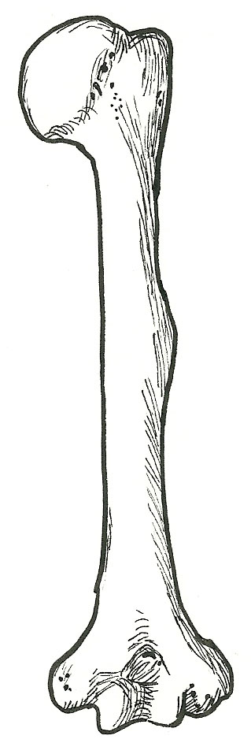
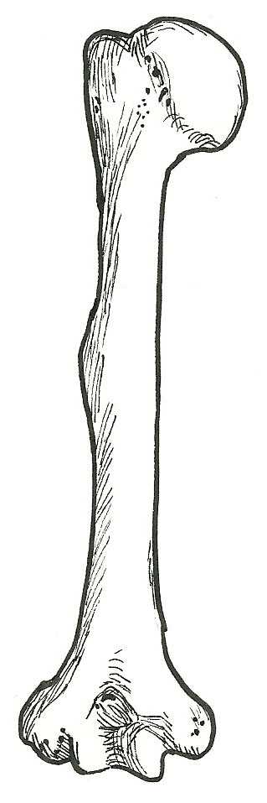
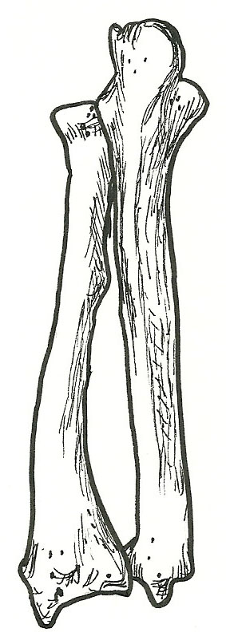
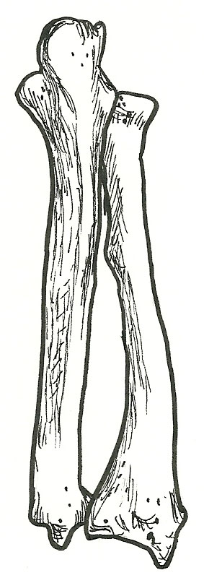
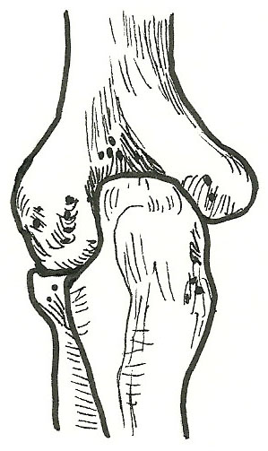
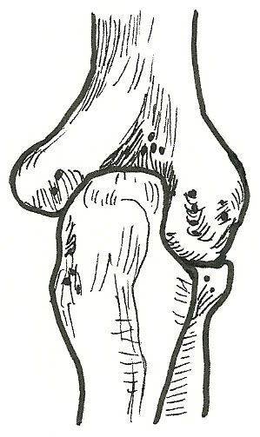
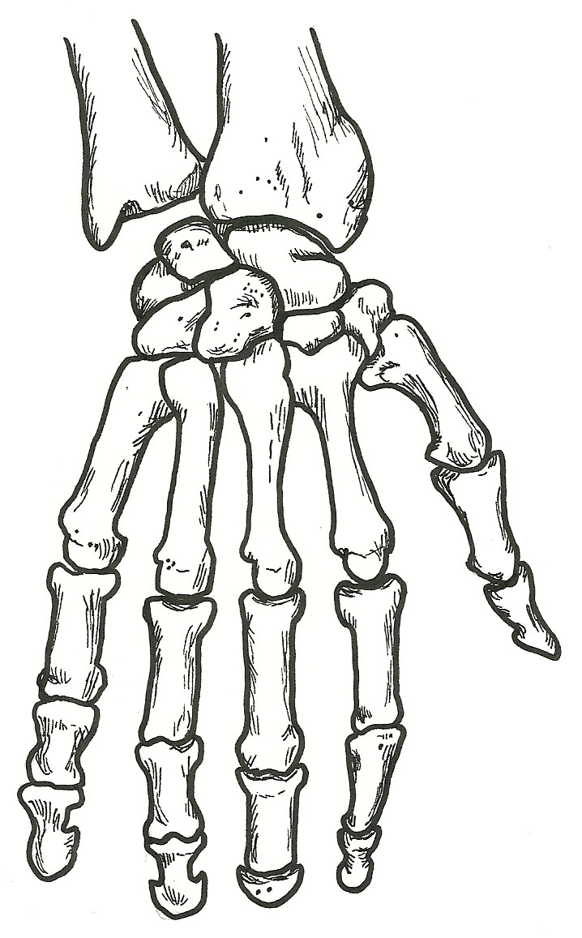
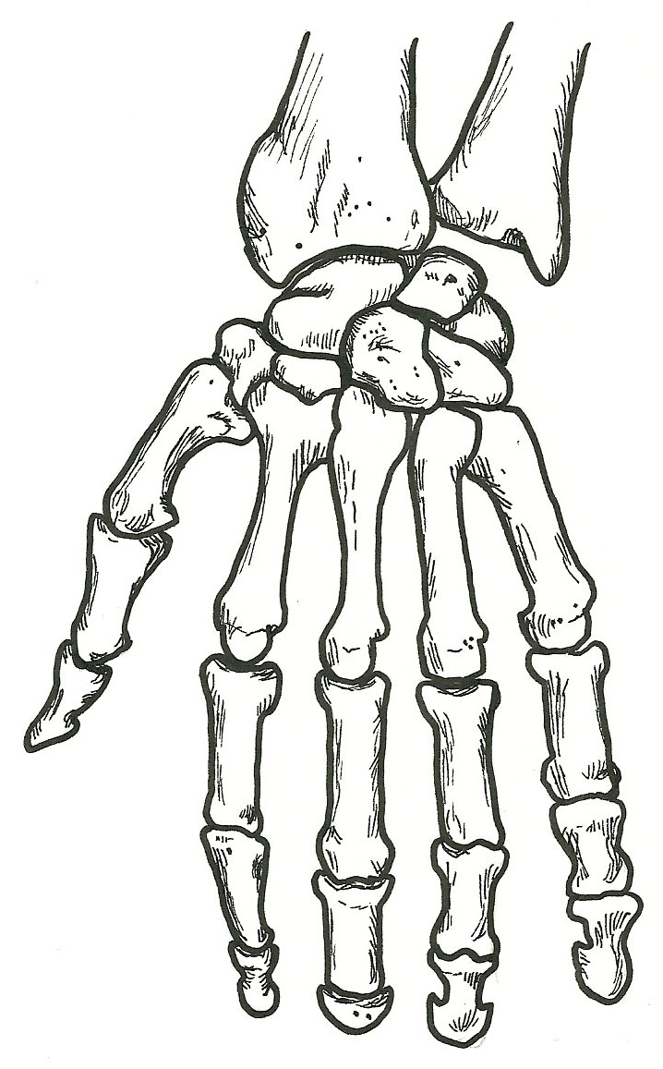
Humerus – posterior view
head (of humerus)
anatomical neck
surgical neck
greater tubercle
deltoid tuberosity
trochlea
olecranon fossa
lateral epicondyle
medial epicondyle

Elbow joint – posterior view
humerus
radius
ulna
olecranon
olecranon fossa
medial epicondyle
lateral epicondyle
head of radius

Radius & Ulna – posterior view
radius
head (of radius)
neck
styloid process
ulna
olecranon
styloid process
proximal radioulnar joint
distal radioulnar joint
interosseous membrane

Hand – dorsal (posterior) view
radius
ulna
carpals
metacarpals
base
shaft
head
phalanges
base
shaft
head
proximal phalanges
middle phalanges
distal phalanges
distal radioulnar joint
radiocarpal joint
intercarpal joint
carpometacarpal joint
metacarpophalangeal joint
interphalangeal joint

