stratified squamous epithelium

slide– esophagus middle section

slide– epithelium stratified squamous
Look for the cells lining the surface.
(some slides are poorly stained and it’s hard to see anything – look for a well stained slide)
Magnification:

( )eyepiece
x( )objective
___________

= ( )total
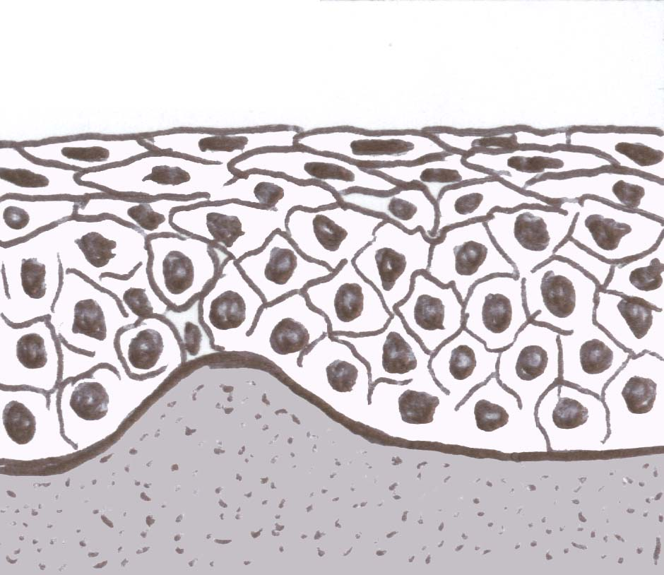
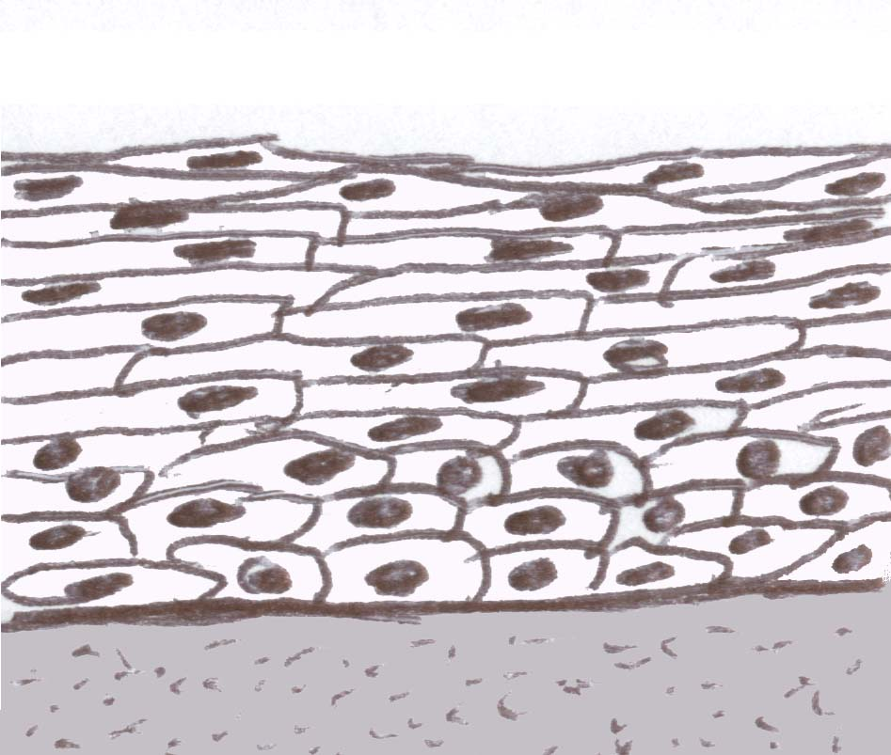

Slide Title = ___________________________

transitional epithelium

slide– epithelium transitional

OR slide– ureter
Look for the cells lining the central opening of the round ureter. When trying to find tissue on the slide at low power (or by holding the slide up to see by eye) – look for a very small dark staining circle of tissue in the center of the slide. Many slides are poorly stained and hard to see – try to avoid those.

Magnification:

( )eyepiece
x( )objective
___________

= ( )total
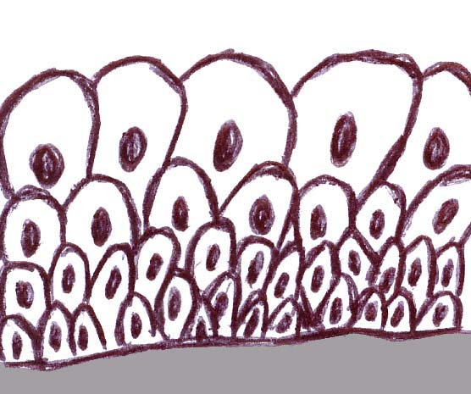
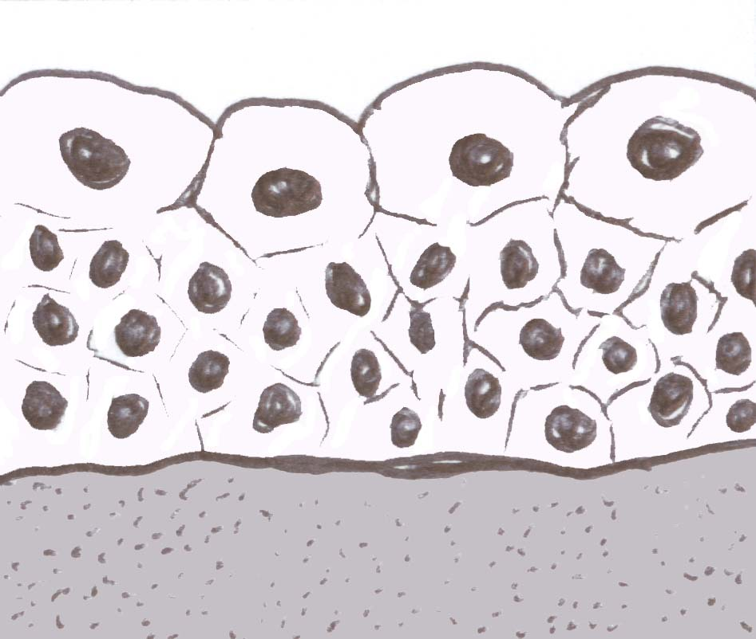

Slide Title = ___________________________

pseudostratified columnar epithelium

slide– PSCCE – pseudostratified ciliated columnar epithelium
OR slide -ciliated epithelium trachea
OR slide -trachea
Look for the cells lining the inner surface. Do NOT focus on the hyaline cartilage or adipose that you can also find on these slides.
Magnification:

( )eyepiece
x( )objective
___________

= ( )total
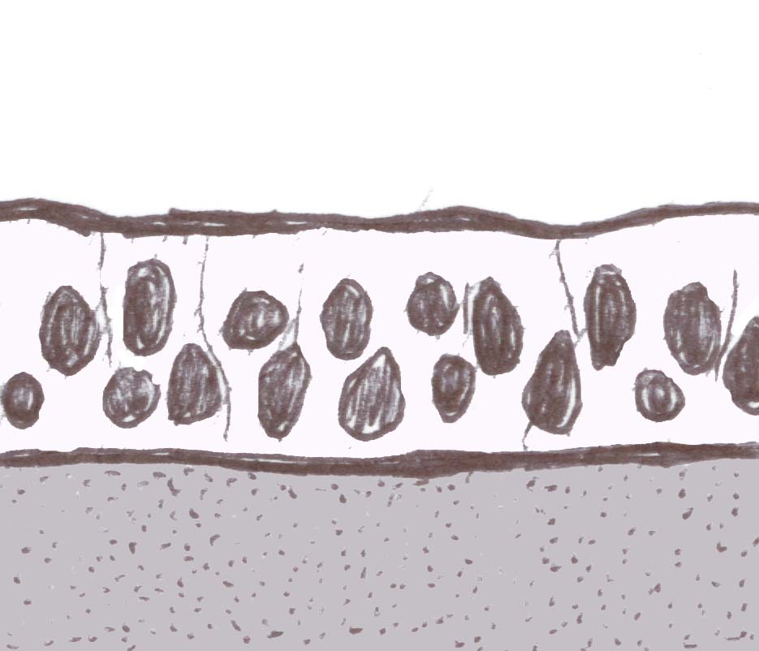
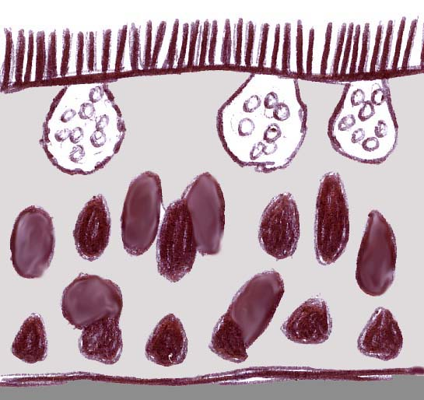

Slide Title = ___________________________
Page 2

