simple squamous epithelium

slide– lung
Look for the walls surrounding the empty spaces of the alveoli in the lungs (simple squamous cells in cross-section).

OR slide– mesothelium silvered
Look almost anywhere in the mesothelium (simple squamous cells – surface view).

Magnification:

( )eyepiece
x( )objective
___________

= ( )total
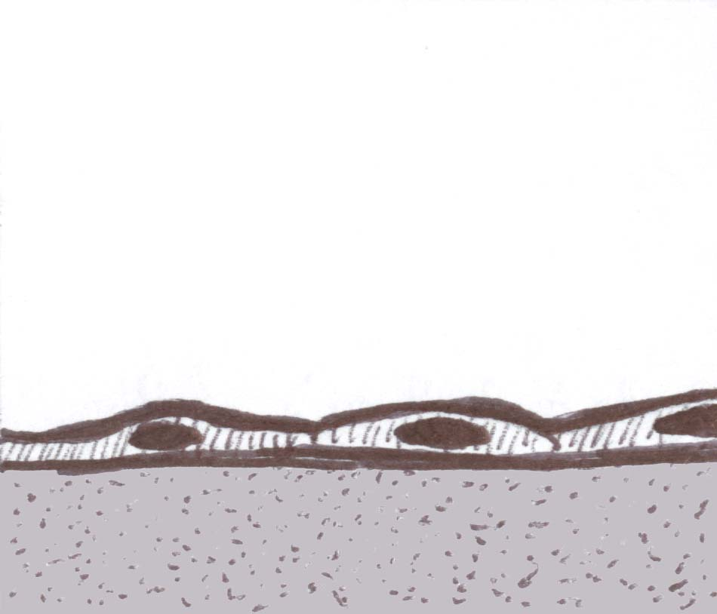
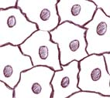
Student
Name:____________________________

Slide Title = ___________________________

simple cuboidal epithelium

slide– cuboidal epithelium thyroid
slide– thyroid
Look for the cells surrounding each pink-filled follicle in the thyroid.

OR slide– simple cuboidal epithelium kidney
Look almost anywhere in the kidney for the walls of tubules.

Magnification:

( )eyepiece
x( )objective
___________

= ( )total
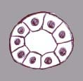
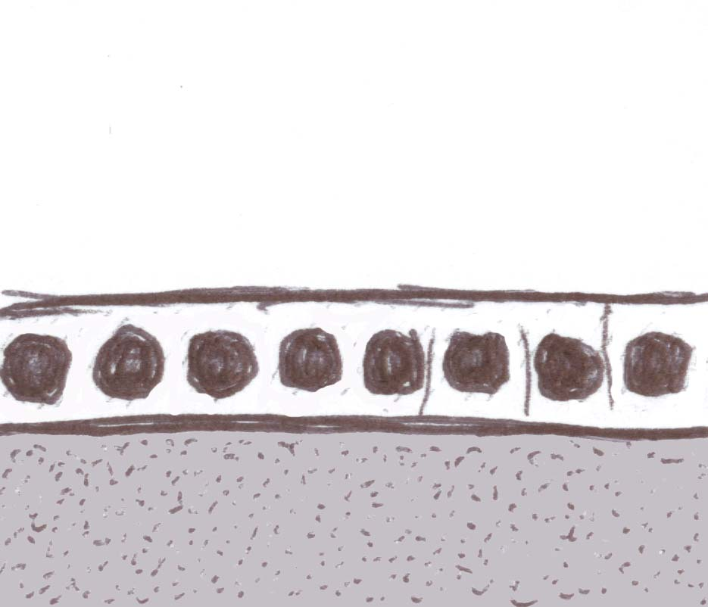

Slide Title = ___________________________

simple columnar epithelium

slide– simple columnar epithelium

OR slide– jejunum
Look for the cells on the surface, lining the intestinal villi – you should be able to see clear mucus / goblet cells interspersed amongst the columnar cells.

Magnification:

( )eyepiece
x( )objective
___________

= ( )total
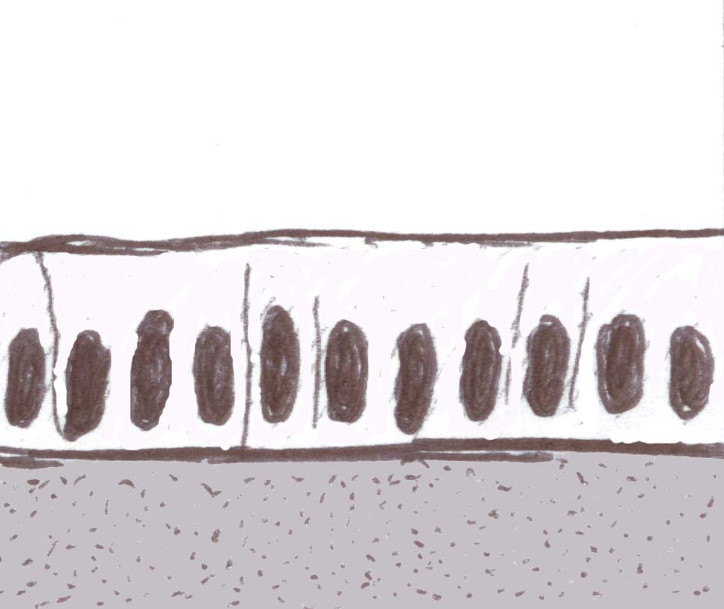
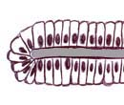

Slide Title = ___________________________
Page 1

