TERES MAJOR

The teres major muscle pulls the

intertubercular sulcus of the humerus (INSERTION)

towards the inferior angle of the scapula (ORIGIN)

causing extension of the upper limb at the shoulder (ACTION)

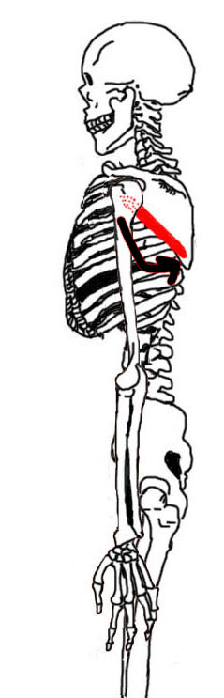

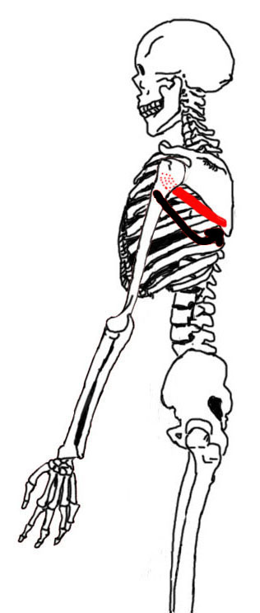

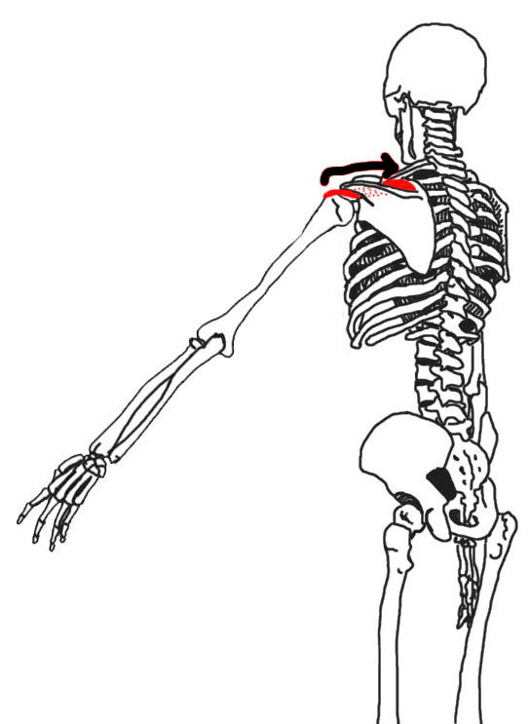

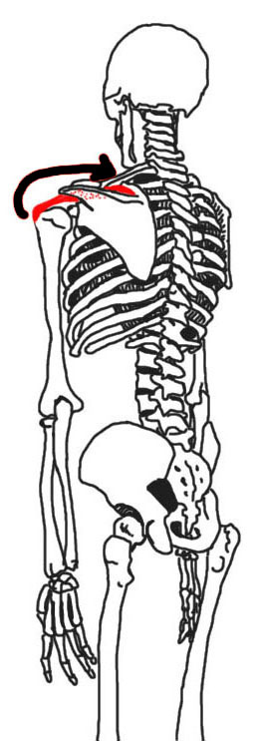

SUPRASPINATUS

The supraspinatus muscle pulls the

greater tubercle of the humerus (INSERTION)

towards the supraspinous fossa of the scapula (ORIGIN)

causing abduction of the upper limb at the shoulder (ACTION)

PECTORALIS MAJOR

The pectoralis major muscle pulls the

greater tubercle and intertubercular sulcus of the humerus (INSERTION)

towards the clavicle, sternum and ribcage (ORIGIN)

causing adduction of the upper limb at the shoulder (ACTION)

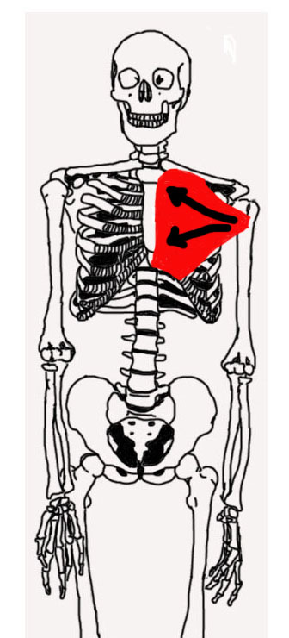

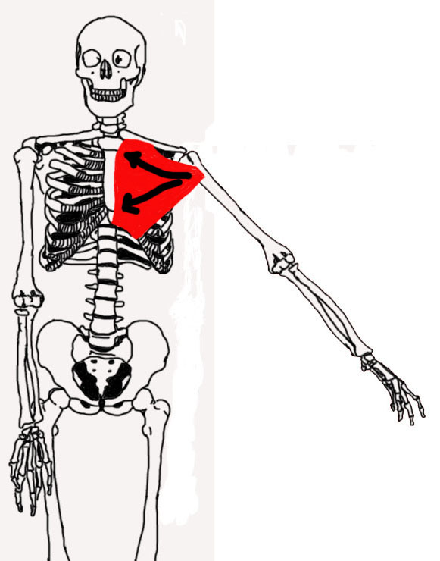

x