ANTERIOR DELTOID

The anterior part of the deltoid muscle pulls the

deltoid tuberosity of the humerus (INSERTION)

towards the clavicle (ORIGIN)

causing flexion of the upper limb at the shoulder (ACTION)

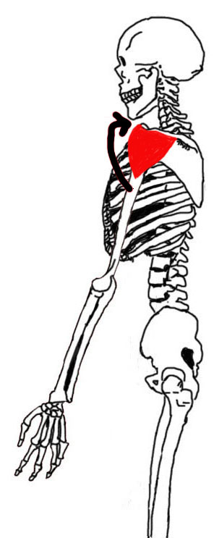

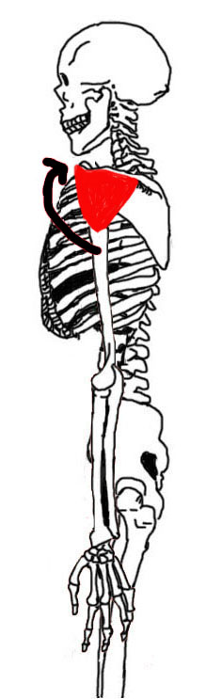

MEDIAL DELTOID

The medial part of the deltoid muscle pulls the

deltoid tuberosity of the humerus (INSERTION)

towards the acromion (ORIGIN)

causing abduction of the upper limb at the shoulder (ACTION)

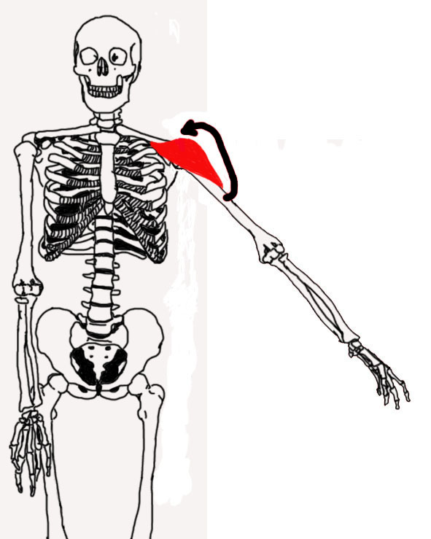

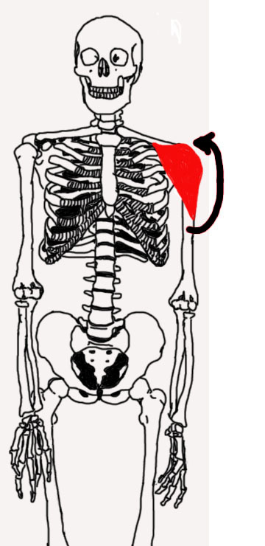

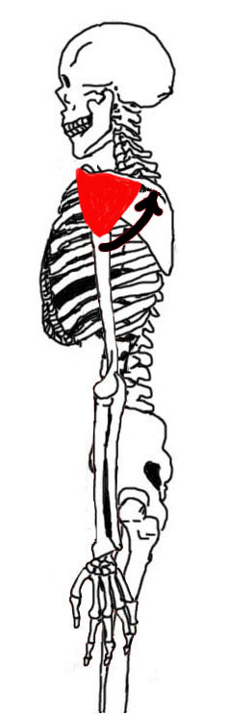

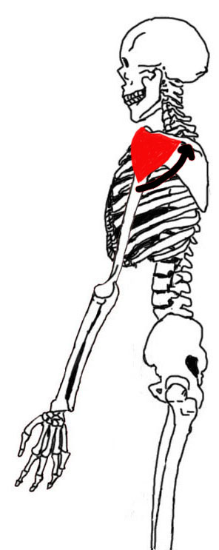

POSTERIOR DELTOID

The posterior part of the deltoid muscle pulls the

deltoid tuberosity of the humerus (INSERTION)

towards the spine of the scapula (ORIGIN)

causing extension of the upper limb at the shoulder (ACTION)